ASSIGNMENT NO. 11

Indexing and Query Optimization

Objective: To create indexes, inspect indexes with SHOW INDEX, use composite indexes, analyze queries with EXPLAIN, and rewrite queries for better index usage.

Q1) Create SalesDB and OrderData and insert at least 12 records.

Column Name | Data Type | Constraint
OrderID | INT | PRIMARY KEY
CustomerName | VARCHAR(50) | NOT NULL
Email | VARCHAR(80) | NOT NULL
City | VARCHAR(30) | NOT NULL
ProductCategory | VARCHAR(30) | NOT NULL
OrderDate | DATE | NOT NULL
OrderAmount | DECIMAL(10,2) | NOT NULL
OrderStatus | VARCHAR(20) | NOT NULL

CREATE DATABASE SalesDB;
USE SalesDB;

CREATE TABLE OrderData ( OrderID INT PRIMARY KEY,
CustomerName VARCHAR(50) NOT NULL, Email VARCHAR(80) NOT NULL,
City VARCHAR(30) NOT NULL,
ProductCategory VARCHAR(30) NOT NULL, OrderDate DATE NOT NULL,
OrderAmount DECIMAL(10,2) NOT NULL,
OrderStatus VARCHAR(20) NOT NULL
);

INSERT INTO OrderData
(OrderID, CustomerName, Email, City, ProductCategory, OrderDate, OrderAmount, OrderStatus) VALUES
(1, 'Rahul Sharma', 'rahul@gmail.com', 'Mumbai', 'Electronics', '2026-01-05', 55000.00, 'Delivered'),
(2, 'Priya Patil', 'priya@gmail.com', 'Pune', 'Furniture', '2026-01-08', 32000.00, 'Delivered'),
(3, 'Aman Verma', 'aman@gmail.com', 'Nashik', 'Clothing', '2026-01-12', 8500.00, 'Pending'),
(4, 'Sneha Joshi', 'sneha@gmail.com', 'Mumbai', 'Electronics', '2026-01-20', 72000.00, 'Delivered'),
(5, 'Karan Mehta', 'karan@gmail.com', 'Thane', 'Furniture', '2026-02-03', 28000.00, 'Cancelled'),
(6, 'Neha Shah', 'neha@gmail.com', 'Pune', 'Electronics', '2026-02-08', 48000.00, 'Delivered'),
(7, 'Rohan Desai', 'rohan@gmail.com', 'Mumbai', 'Clothing', '2026-02-15', 12000.00, 'Pending'),
(8, 'Meera Kulkarni', 'meera@gmail.com', 'Nashik', 'Furniture', '2026-02-22', 36000.00, 'Delivered'),
(9, 'Arjun Nair', 'arjun@gmail.com', 'Thane', 'Electronics', '2026-03-02', 64000.00, 'Shipped'),
(10, 'Divya More', 'divya@gmail.com', 'Mumbai', 'Furniture', '2026-03-07', 41000.00, 'Delivered'),
(11, 'Isha Singh', 'isha@gmail.com', 'Pune', 'Clothing', '2026-03-12', 15000.00, 'Shipped'),
(12, 'Om Jadhav', 'om@gmail.com', 'Mumbai', 'Electronics', '2026-03-18', 59000.00, 'Pending');

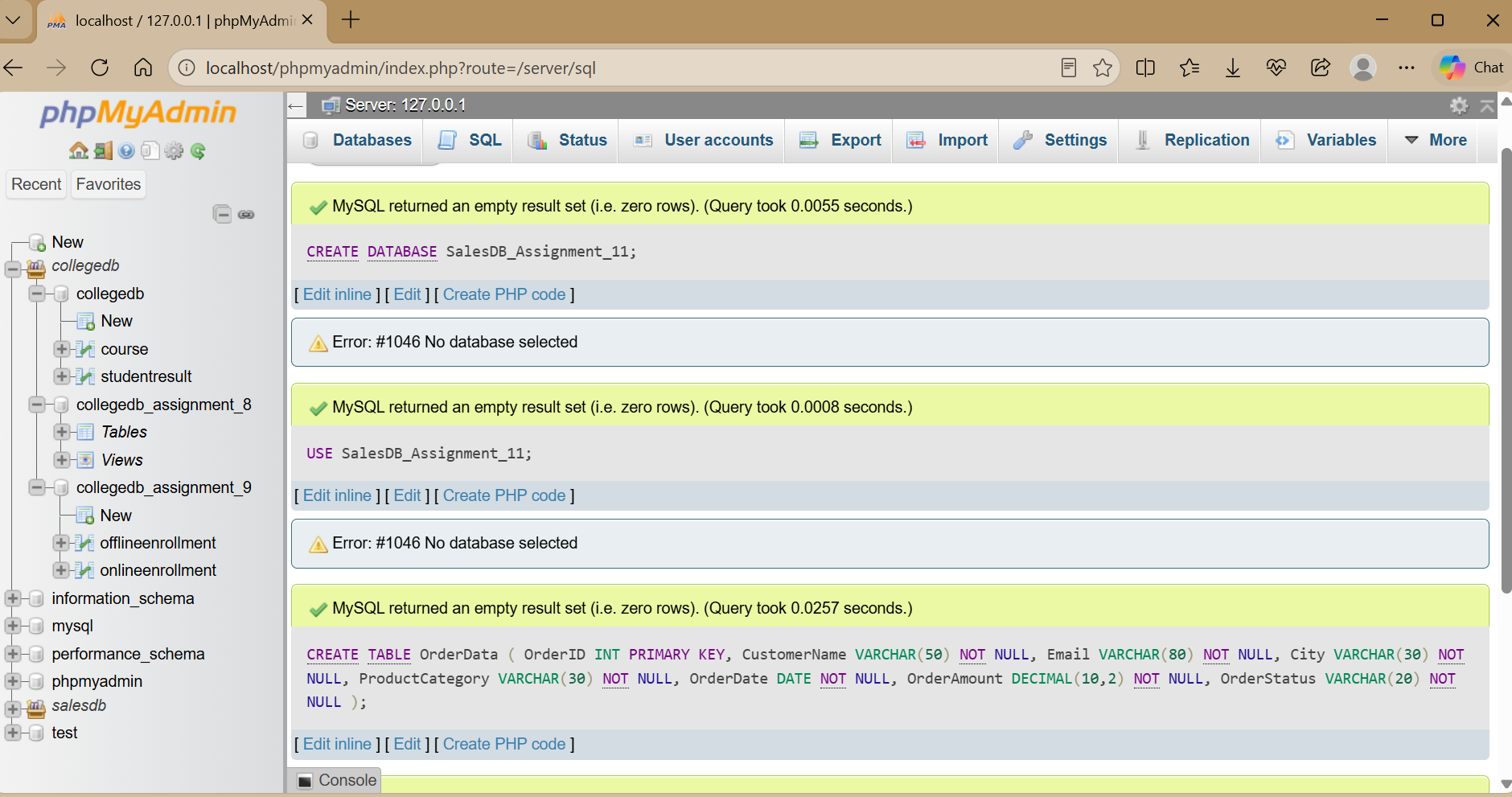

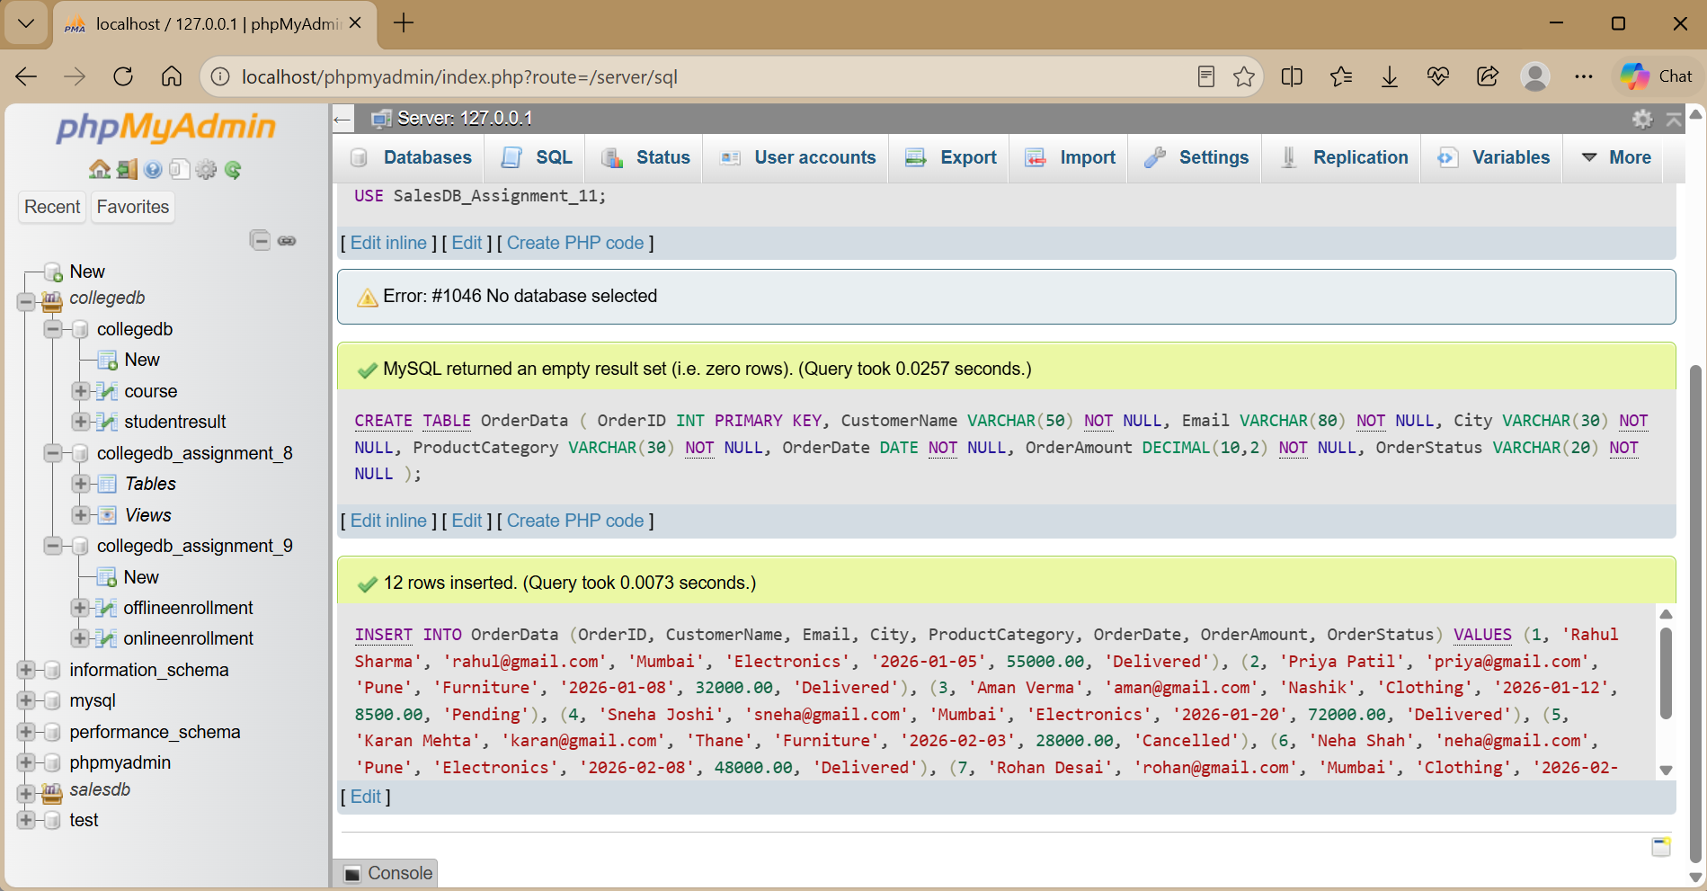

Q2) Create idx_city, idx_email, and idx_order_date and display all indexes.

CREATE INDEX idx_city ON OrderData(City);

CREATE UNIQUE INDEX idx_email ON OrderData(Email);

CREATE INDEX idx_order_date ON OrderData(OrderDate);

SHOW INDEX FROM OrderData;

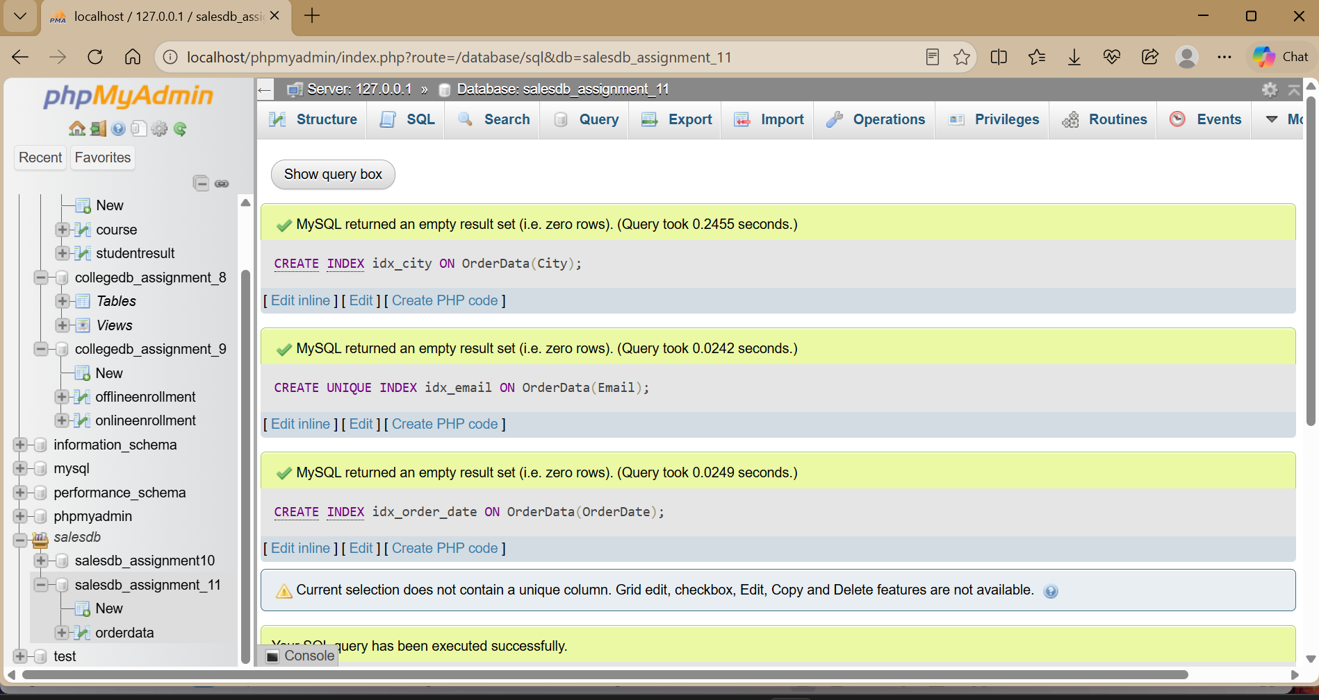

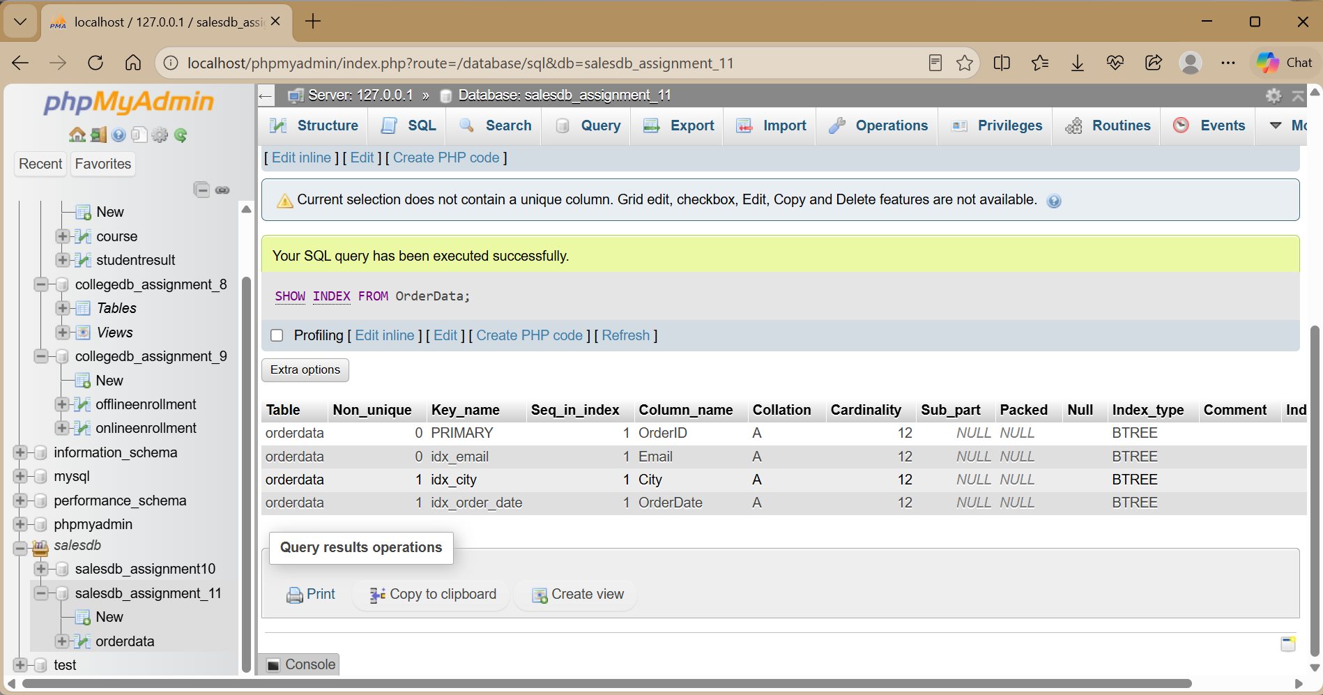

idx_city is a normal index, idx_email is a unique index, and idx_order_date is a normal date index.
Q3) Create composite index idx_city_order_date and search Mumbai orders within a date range.

CREATE INDEX idx_city_order_date ON OrderData(City, OrderDate);

SELECT OrderID, CustomerName, City, OrderDate, OrderAmount FROM OrderData
WHERE City = 'Mumbai'
AND OrderDate BETWEEN '2026-01-01' AND '2026-03-31';

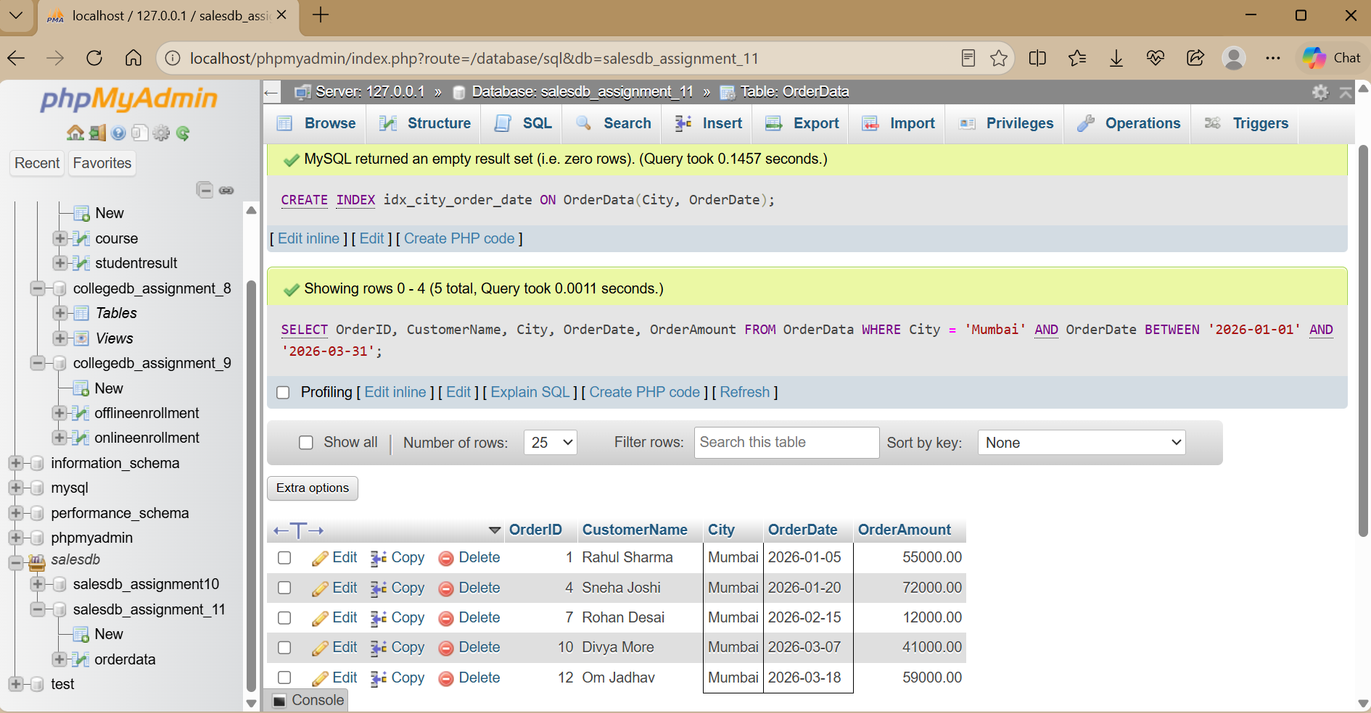

The composite index contains City first and OrderDate second. It is suitable for queries that use City together with an OrderDate condition.

Q4) Use EXPLAIN to analyze a City search.

EXPLAIN SELECT *
FROM OrderData
WHERE City = 'Mumbai';

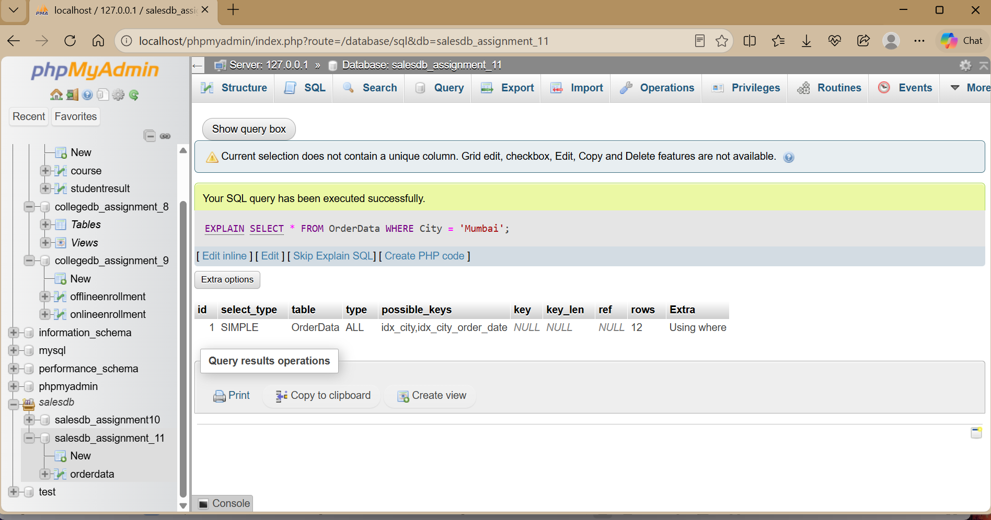

Important EXPLAIN columns to record:

EXPLAIN Column | Meaning
type | Access method used by MySQL
possible_keys | Indexes MySQL may consider
key | Index actually selected
rows | Estimated rows examined
Extra | Additional execution information

Q5) Compare query performance before and after creating idx_city.

Step 1 — Drop the index if it exists:

DROP INDEX idx_city ON OrderData;

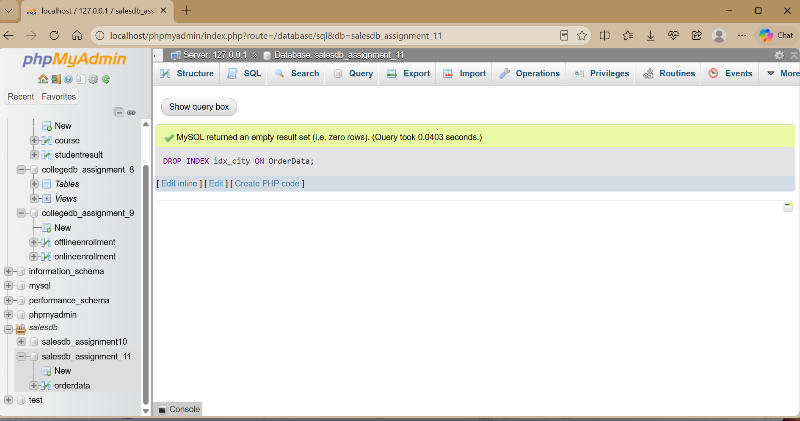

Step 2 — Run EXPLAIN without the index:

EXPLAIN SELECT *
FROM OrderData
WHERE City = 'Mumbai';

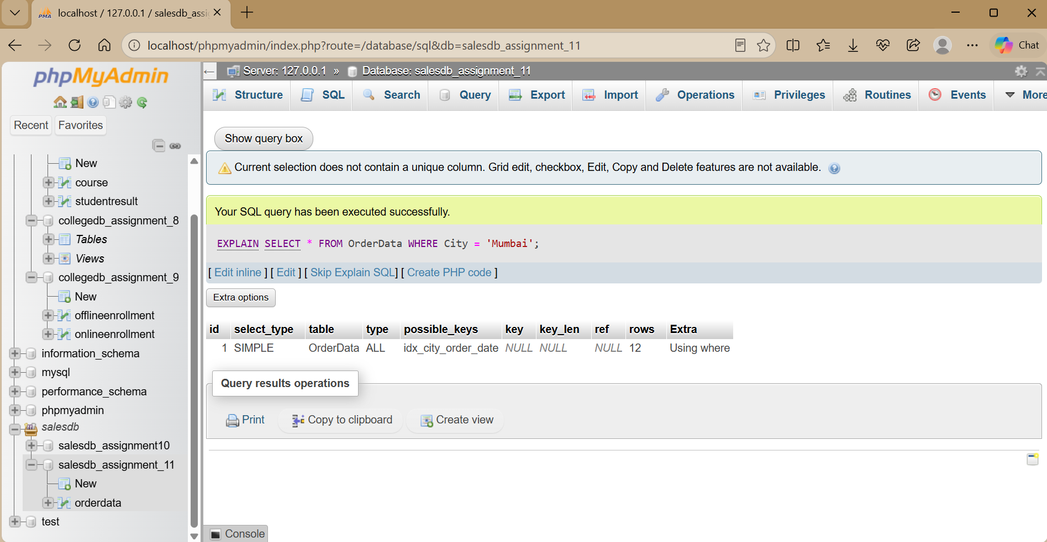
Step 3 — Create the index:

CREATE INDEX idx_city ON OrderData(City);

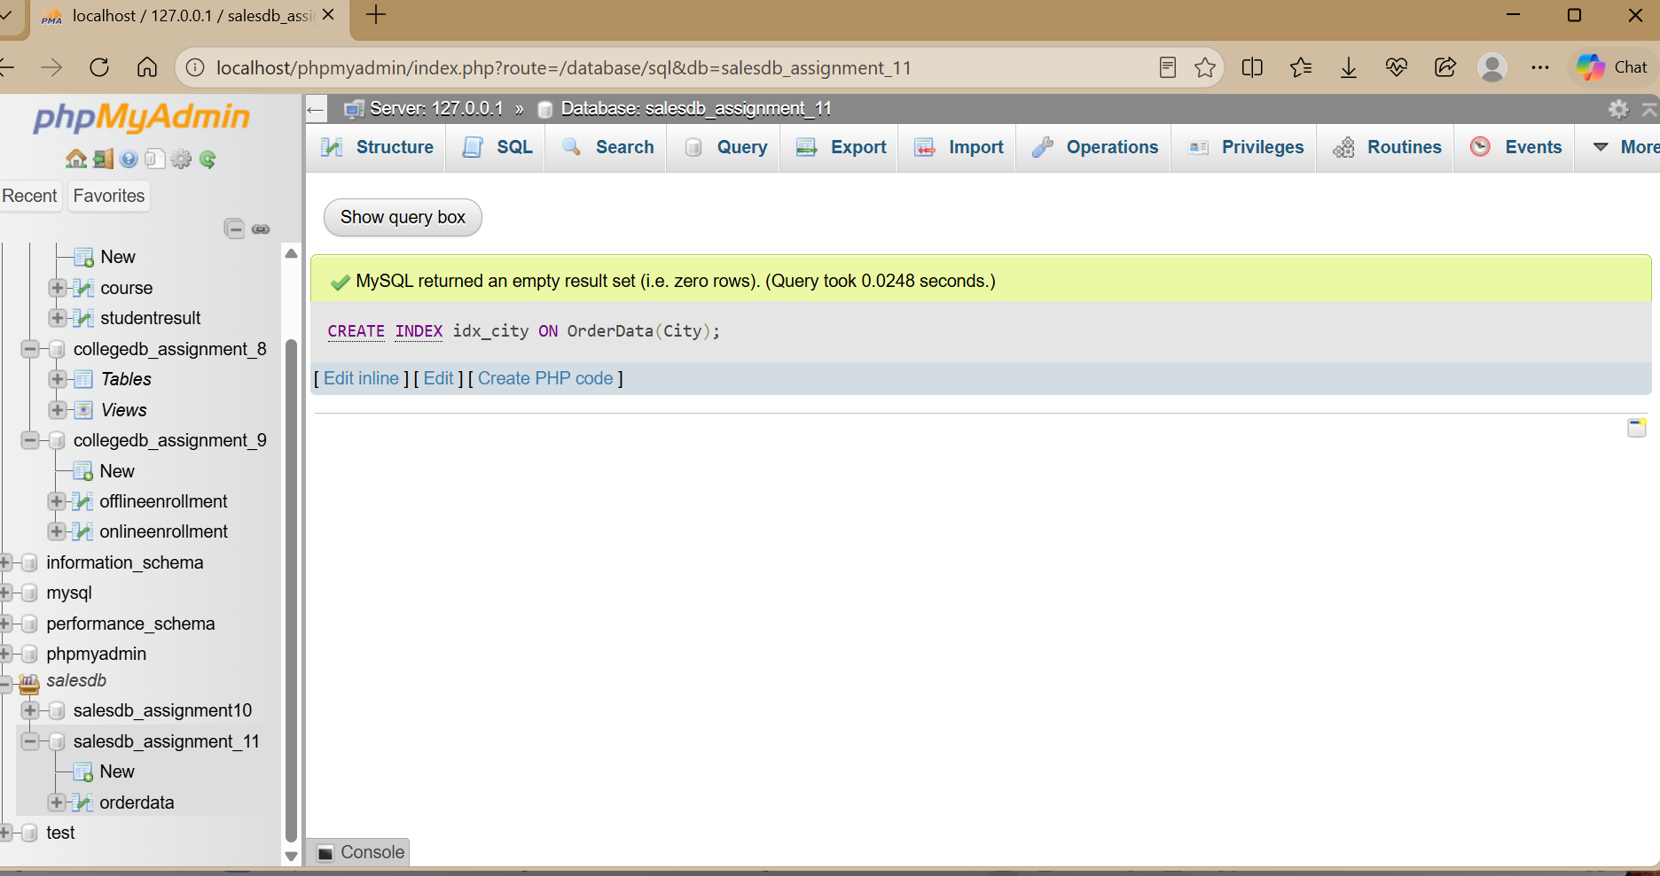

Step 4 — Run the same EXPLAIN query again:

EXPLAIN SELECT *
FROM OrderData
WHERE City = 'Mumbai';

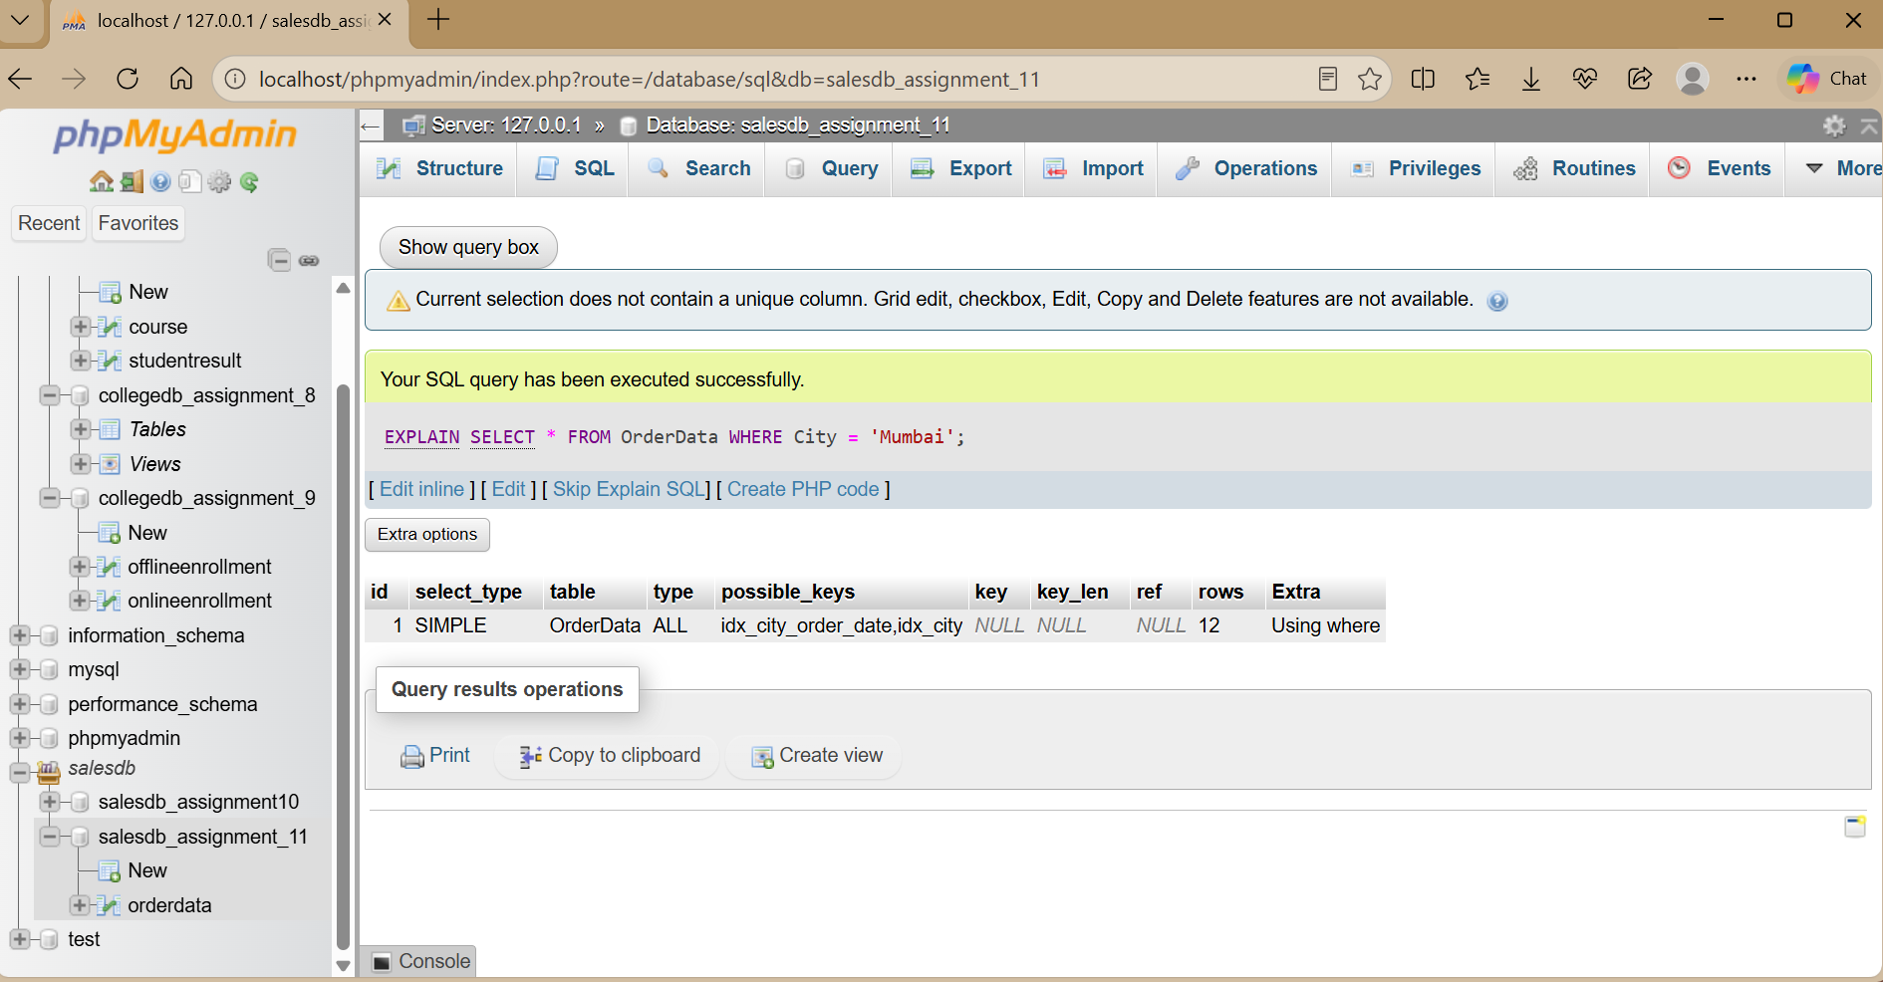
Step 5 — Compare type, possible_keys, key, rows, and Extra. The exact plan can vary because MySQL's optimizer considers the table size, statistics, selectivity, and available indexes.

Column | Without Index (DROP INDEX) | With Index (CREATE INDEX)
type | ALL | ref | ALL means full table scan (slowest). ref means index lookup (much faster)
possible_keys | NULL | idx_city (or idx_city_order_date) | Lists which indexes MySQL can choose from.
key | NULL | idx_city | Shows the index MySQL actually decided to use for execution
rows | 12 (Total rows in table) | 4 (Only matching rows) | Without an index, MySQL reads every single row in the table. With an index, it reads only the relevant rows.
Extra | Using where | NULL or Using index condition | Additional internal execution details.

Q6) Rewrite YEAR(OrderDate) = 2026 in an index-friendly form.

SELECT OrderID, CustomerName, OrderDate, OrderAmount FROM OrderData
WHERE OrderDate >= '2026-01-01' AND OrderDate < '2027-01-01';

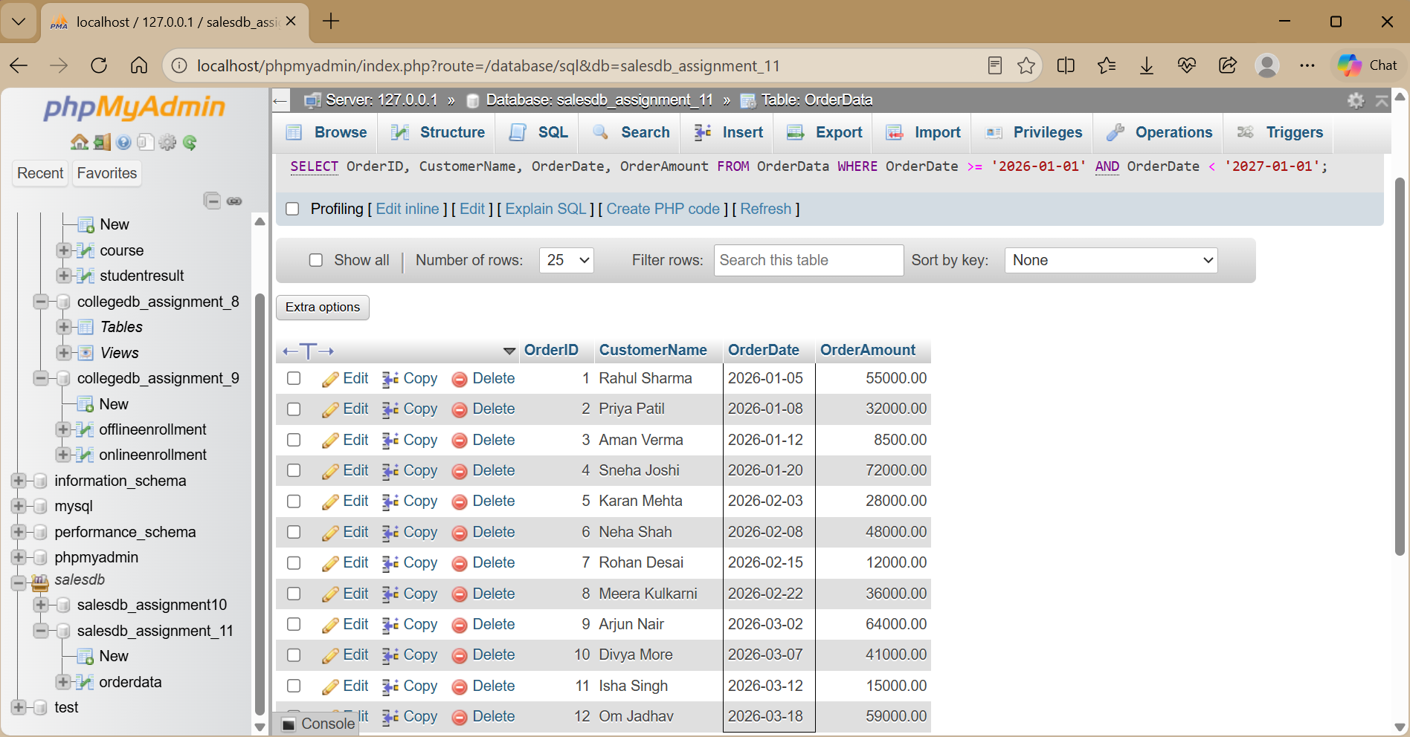

This avoids applying YEAR() to the indexed OrderDate column and uses a direct date range.
It can then be analyzed with EXPLAIN:

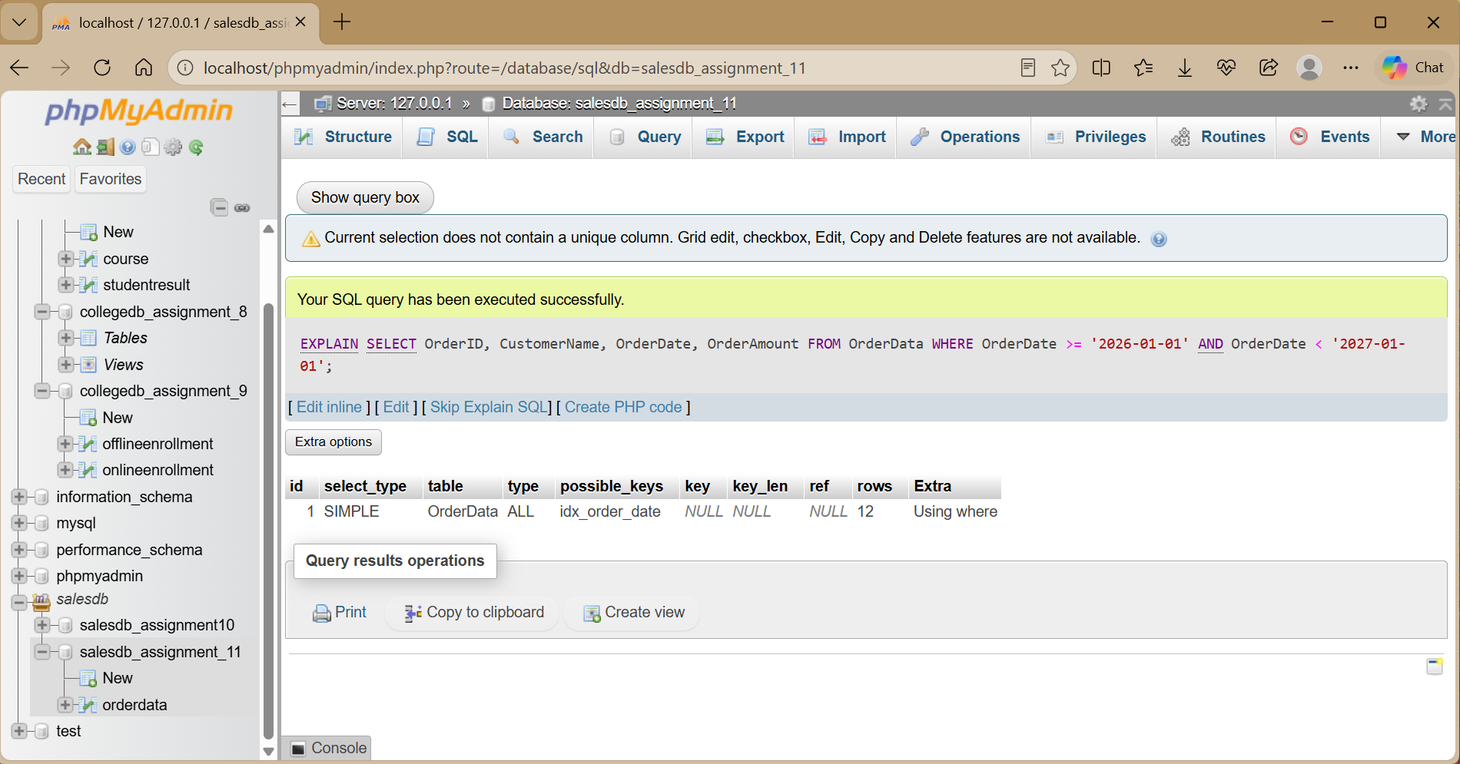

THANK YOU

